We Don’t Need Entries — We Need Better Stops

26-2-5 | We Don’t Need Entries — We Need Better Stops
BTC Chart
Based on today’s overall market behavior, one thing becomes very clear:
Moving the stop loss (trailing stop) is not about making more money — it is about surviving in an uncertain market.

1️⃣ BTC
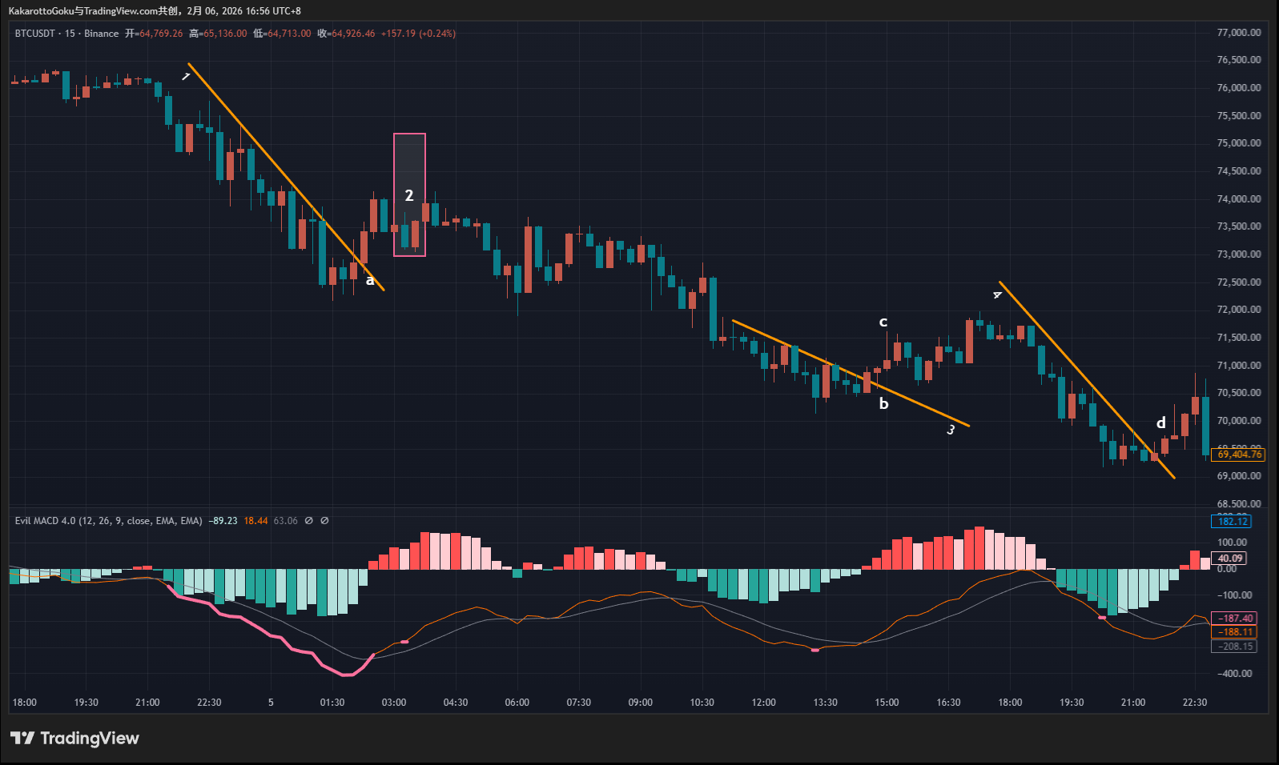
BTC Chart
BTC first showed a red warning line, indicating a potential bottom area (not a confirmed reversal). Price then broke above the trendline at point A, which structurally provided a reference for possible entry.
However, this breakout did not sustain for long. Around area 2, strong bearish momentum quickly emerged.
If one chose to follow the entry at point A, it became necessary to dynamically adjust the stop loss as price evolved — in other words, to trail the stop in order to protect floating profits or at least secure a breakeven exit.
When market conditions show clear signs of fading momentum and strong two-sided competition, prioritizing stop adjustment is always more important than holding and hoping.
Later, near trendline 3, another pink bottom warning appeared, followed by an upward breakout at point B. However, the quality of this breakout was relatively weak:
- The candles before point B broke the trendline very marginally, with closes nearly touching the line
- The candle at point B itself was a small-bodied pin bar
- The candle at point C showed a bearish pin bar with a long upper wick
These two candles clearly indicate a strong consolidation and battle between buyers and sellers, making this a low-quality entry area.
If an entry was taken here, it would again require active stop trailing to protect any unrealized gains, rather than expecting smooth continuation.
Finally, another red bottom warning appeared below trendline 4, and price broke upward at point D. Structurally, this was a relatively clean bottom breakout, and the entry logic itself was reasonable.
The issue arose from the price action after point D:
- The first candle showed an extremely long upper wick, forming a clear bearish pin bar
- The second candle pushed upward but failed to break above the prior wick high
- The third candle again formed a noticeable upper wick, with wick length approaching or exceeding the body
This sequence of candles suggests that bullish momentum was not dominant, and uncertainty increased significantly. Under such conditions, trailing the stop to lock in profits and reduce drawdown risk is the more rational response.

2️⃣ ETH
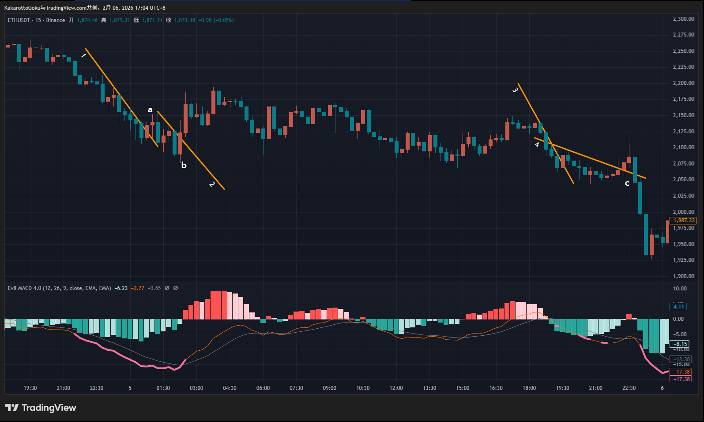
ETH Chart
ETH first displayed a continuous pink warning zone, indicating a potential bottom area. A trendline 1 was then drawn and broken upward at point A.
However, several details are worth noting:
- The candles before point A broke the trendline very weakly
- The closing prices were extremely close to the trendline
- The candle at point A itself was a doji-like structure with a long upper wick
This type of candle typically reflects indecision rather than trend confirmation, making it a poor entry candidate.
A trendline 2 then appeared and was broken upward at point B. However, trendline 2 itself had not been validated by price, making its quality even lower than trendline 1. In this case, waiting and observing remained the more reasonable choice.
If one chose to follow the breakout at point B, the stop loss would need to be moved aggressively as price progressed. Without trailing the stop — or when using a fixed risk–reward model — the renewed bearish pressure later on would likely result in a stop-out.
A breakout also occurred at trendline 3, but the quality was again weak, with the close positioned very close to the trendline. This setup could reasonably be skipped. Even if entered, it carried a high probability of becoming a losing trade, depending on initial stop placement.
Finally, trendline 4 was broken upward at point C, with a relatively cleaner breakout. However, immediately after point C, a near-doji candle appeared, with the combined wick length clearly exceeding the candle body.
This candle represents intense two-sided competition. Upon seeing such price action, the more appropriate response is to trail the stop and protect existing profits, rather than allowing random market fluctuations to hit the original stop loss.

3️⃣ Gold
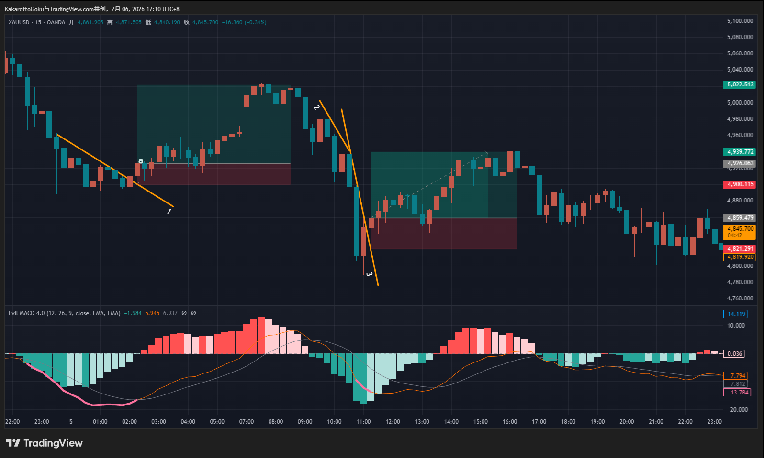
Gold Chart
Compared to BTC and ETH, gold offered significantly higher-quality trading opportunities today.
A thick pink bottom warning zone appeared first, indicating a potential bottom area. Price then broke above trendline 1 at point A. Both the candle quality and the breakout structure were clearly superior to those seen in BTC and ETH, making this a more reasonable follow-entry opportunity.
Under this structure, continuous stop trailing allowed for the possibility of achieving a more favorable risk–reward outcome.
It is important to clarify that area 2 is not a valid trendline, but rather an unformed and unverified structure, drawn only to illustrate the difference between confirmed and unconfirmed trendlines.
During unformed trendline phases, price often deviates significantly. Only after trendline 3 formed did the structure begin to stabilize. However, trendline 3 was still newly formed and had not yet been validated by the market.
When trendline 3 was broken upward, observing rather than entering was a reasonable choice. Additionally, the breakout candle showed a clear upper wick and a near-doji structure, reflecting strong disagreement between buyers and sellers. As such, this opportunity could also be skipped.

Summary
Today’s market action clearly demonstrates that:
- Not every signal requires an entry
- Not every entry will develop as expected
- The market is inherently uncertain and can reverse at any time
Therefore, the primary objective in trading should always be:
Risk control, drawdown reduction, and capital preservation.
Many setups may appear tradable on the surface but lack sufficient quality. In the absence of high-probability opportunities, staying flat is often the optimal decision.
Trading opportunities vary in quality. By continuously filtering and refining one’s trading system and focusing only on higher-probability structures, a more sustainable long-term approach can be achieved.

